Global Weather API Specification

Contents

What is Global Weather API? 3

Technical Design 3

API Calls: 4

GET: /cities:- 4

GET: /weather:- 5

What is Global Weather API?  
  
The Global Weather API is a REST (Representational State Transfer) based API (Application Program Interface) providing the clients of this to get / query the cities of a country and their weather.  
This API accepts / produces JSON (Javascript Object Notation).

Technical Design  
  
API Flow Diagram:  
  
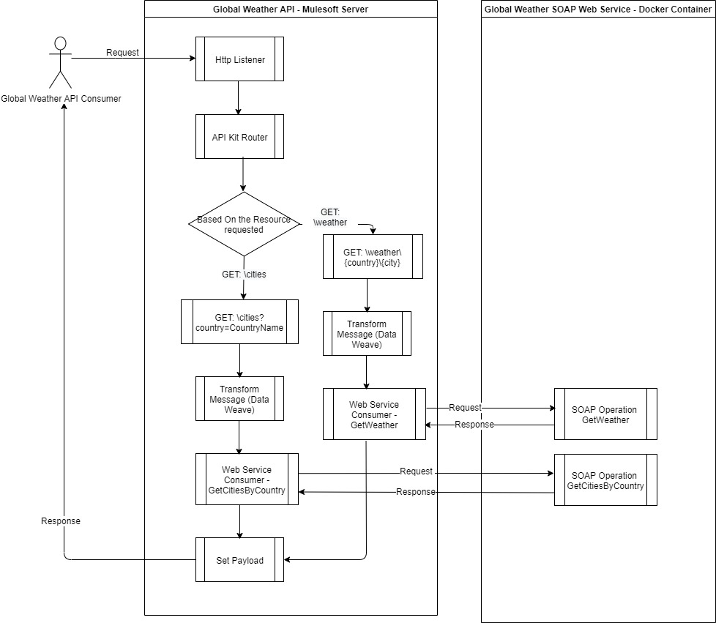=

## API Calls:

## 

*Base URI*: <http://localhost:8081/api>

GET: /cities:-  
  
Resource: cities

Request Description:

|  |  |  |  |
| --- | --- | --- | --- |
| **Field Name** | **Type** | **Required** | **Description** |
| country | *String* | *Required* | *Passed as URI parameter* |

Example: <http://localhost:8081/api/cities?country=australia>

Response Description:  
  
Success Sample Response: 200 OK

{

“country”:”Australia”,

“cities”: ["Sydney", "Melbourne", "Brisbane"]

}

Error Sample Response: 400 Bad Request

{

"statusCode": "400",

"message": "Bad Request"

}

Error Sample Response: 404 Not Found

{

"statusCode": "404",

"message": "Data not found"

}

GET: /weather:-  
  
Resource: weather

Request Description:

|  |  |  |  |
| --- | --- | --- | --- |
| **Field Name** | **Type** | **Required** | **Description** |
| country | *String* | *Required* | *Passed as URI parameter. Ex: Australia* |
| City | *String* | *Required* | *Passed as URI parameter. Ex: Melbourne* |

Example: <http://localhost:8081/api/weather/australia/sydney>

Response Description:  
  
Success Sample Response: 200 OK

{

"Location": "Sydney",

"Time": "10:00 AM",

"Wind": "5km per hour",

"Visibility": "10km",

"SkyCondition": "sunny",

"Temperature": "25",

"DewPoint": "2 C",

"RelativeHumidity": "35",

"Status": "Normal"

}

Error Sample Response: 400 Bad Request

{

"statusCode": "400",

"message": "Bad Request"

}

Error Sample Response: 404 Not Found

{

"statusCode": "404",

"message": "Data not found"

}